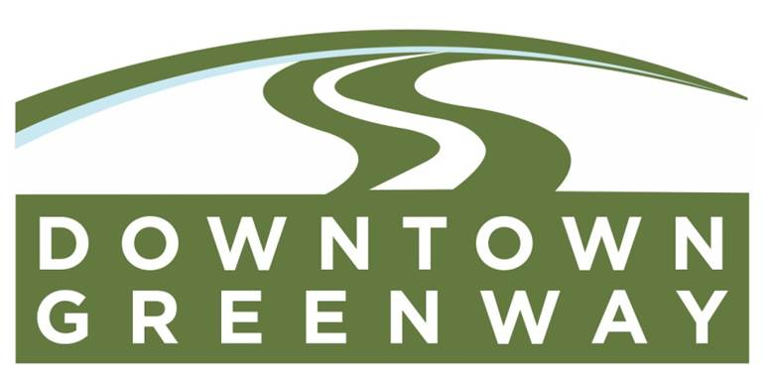
FOR IMMEDIATE RELEASE

Media contacts: Davis Rhorer
225-389-5520
drhorer@brgov.com

Downtown Greenway, North Boulevard Promenade Ribbon Cutting

BATON ROUGE, LA (December 28, 2016) – The North Boulevard Promenade section of the Downtown Greenway has opened following a Ribbon Cutting Ceremony that took place yesterday at 5:00PM on North Boulevard. The Downtown Greenway is a 2.75 mile interconnected network of bike/pedestrian pathways connecting Baton Rouge’s public parks and recreational facilities, inner city communities, and cultural attractions through the use of greenways, or linear parks. The multi-phased, alternative transportation project will utilize the existing BREC parks, interstate infrastructure, and public right-of-ways. It creates the link to over 7 local parks – Memorial Stadium, Expressway Park, Brooks Park and City Park, Arsenal Park, Convention Street Park, Seventh Street Senior Citizens Park – strengthening the social cohesion, promoting community revitalization and adding economic value to Baton Rouge communities. The Downtown Development District is the lead agency responsible for administering the Downtown Greenway project, in partnership with the East Baton Rouge City-Parish, BREC, and the Capitol Area Finance Authority.

The concept for the Downtown Greenway began in Plan Baton Rouge II as a public, alternative transportation system that connects the surrounding inner city neighborhoods to the ‘Central Green,’ a system of greenspaces in the heart of Downtown Baton Rouge that includes North Boulevard Town Square, Repentance Park, City Hall Plaza, and Riverfront Plaza. Influenced by Plan Baton Rouge II’s recommendation, a Feasibility Study was conducted by ABMB Engineers, Inc. to determine viable locations and estimate total cost. In 2012, the City-Parish of Baton Rouge and the Downtown Development District were awarded a technical assistance grant from the Environmental Protection Agency’s (EPA) Greening America’s Capitals Program to fund the schematic plan created by Spackman, Mossop, & Michaels + Tipton Associates. The final design and construction documents were created by Design Workshop and their sub-consultants including; Reich Associates, Fenstermaker, Forte & Tablada, Walter Kulash, and Chris Davala.

The North Boulevard Promenade section of the project was constructed by Rotolo Consultants Inc. and has transformed the meandering brick path into an urban transportation corridor for pedestrians and bicyclists. The project features a 12’ wide bicycle path and complementary separate pedestrian path or garden walk. Thousands of plants were installed and highlight the beautiful oaks along the boulevard. Water fountains, benches, and bike racks are provided, as well as exercise equipment and signage. The project features green painted bike lanes and crossings, which is a first for the State of Louisiana; having been approved by DOTD.

Approximately $3 million dollars has been acquired from national, state, and local grant resources to plan and/or construct the Downtown Greenway including: FHWA Louisiana Recreational Trails Program, LA-DOTD Transportation Enhancement Program, LA-DOTD Transportation Community and System Preservation, EPA Greening America’s Capitals Program, and the Capital Area Finance Authority. The construction of the North Boulevard Promenade portion of the Downtown Greenway was funded by an approximately $1.5 million grant provided by the Louisiana Department of Transportation’s Transportation Community and System Preservation Program (TCSP) Program.

Construction on the Downtown Greenway sections at Expressway Park and Myrtle Street have been completed in 2015 utilizing two grants from the FHWA Louisiana Recreational Trails Program. The Expressway Park project, a partnership between the DDD/City-Parish and BREC, included a 700’ linear foot, 12’ wide path with trailhead facilities, bike racks, accessible ramps, work out station, and connections to the park’s other amenities. A multi-use path was also installed along Myrtle Street, connecting the Lincoln Theatre to the Downtown Greenway at Expressway Park, as part of a partnership between the DDD/EBR City-Parish and the EBR Redevelopment Authority.

“The Downtown Greenway is a shining example of how alternative transportation methods are being implemented in our city to create safe and attractive places for all people to travel and recreate. It will promote healthy lifestyles and also stimulate the economy of the surrounding neighborhoods by creating a recreational destination and commute opportunities for the area work force.” - Mayor-President Melvin "Kip" Holden

The Downtown Greenway will promote recreation and become the backbone of an urban trail system that is built primarily on neighborhood streets, boulevards, and dedicated paths that offer multiple route options catering to all abilities. Making the streets greener, more pleasant, and more comfortable places to travel, the greenway will reinvigorate downtown and surrounding neighborhoods by expanding walking and bike opportunities from City Park to the downtown area.

“The vision of the Downtown Greenway began with Plan Baton Rouge II, to connect our inner city neighborhoods through the creation of a bicycle and pedestrian system. It not only provides recreational benefits, but also a means to commute to downtown workforce opportunities. We are grateful to the local, state, and federal funders and officials whose support is helping to make this vision a reality.”- DDD Executive Director Davis Rhorer

Completion of the Downtown Greenway at East Boulevard/TJ Jemison Boulevard is set for the end of 2017.

#

